**1) Well-structured, and optimized CRUD Operation for Student List using CodeIgniter 3 (30 Marks)**

https://drive.google.com/file/d/1QKdfzMh7RPz_XC4pTqmsCwE0jxg4WeZb/view?usp=sharing

**2) Debugging & Error Handling (20 Marks)**

print_r()  
die();  
var_dump()

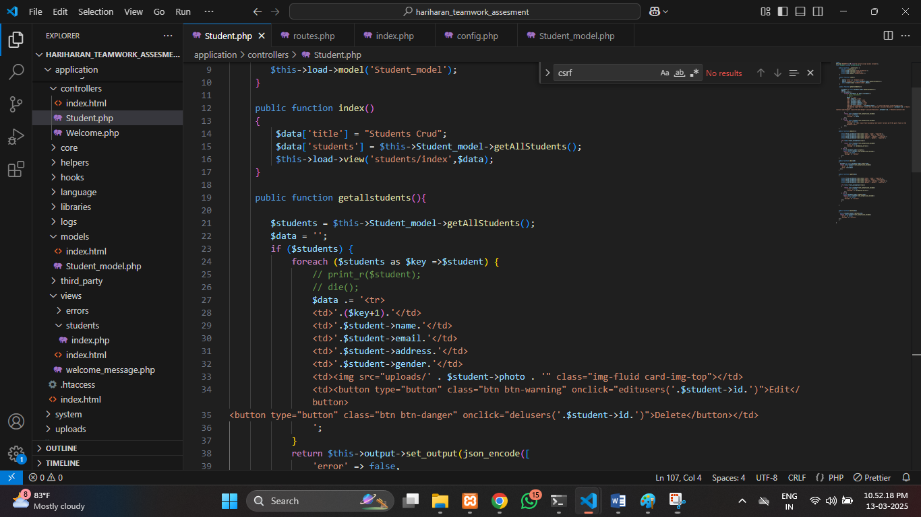

Loggging:

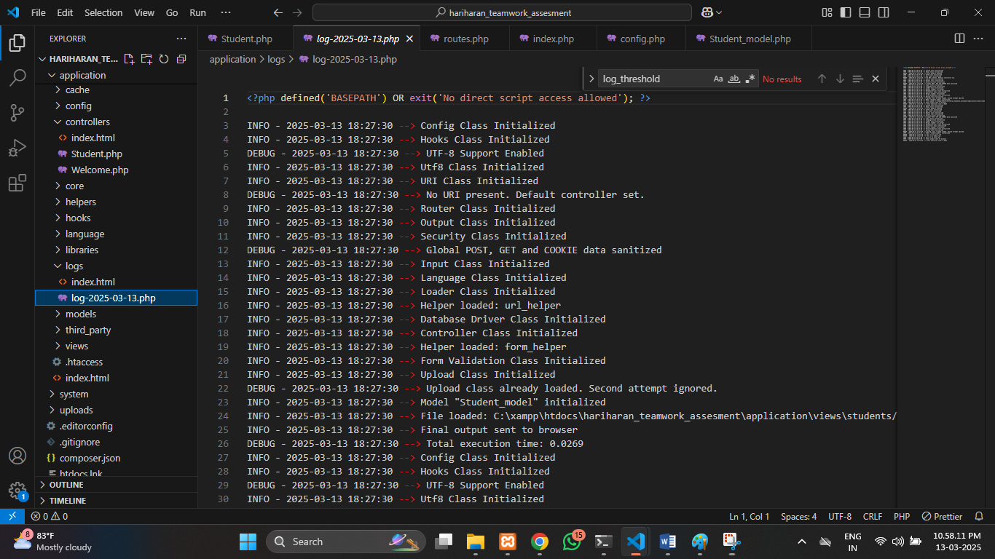

**3) Prevent SQL Injection (20 Marks)**

1.Initially trim and sanitize the input fileds  
eg: username and password

2. Using query builder

Eg:$this->db ….

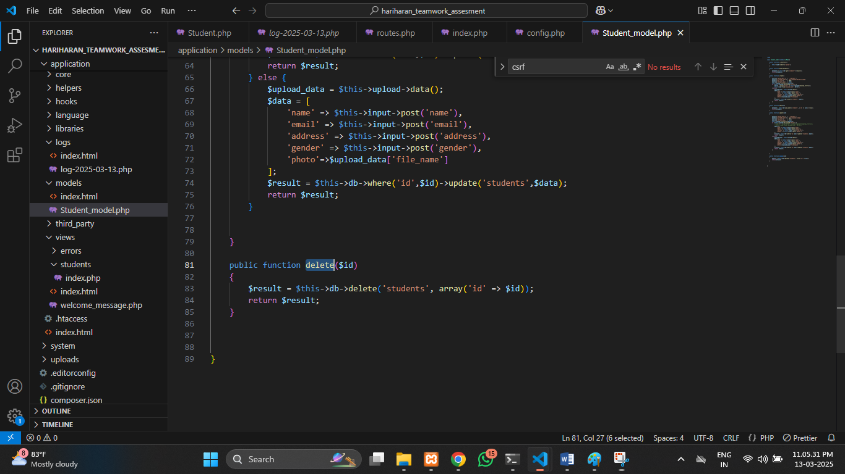

**4) Implement Security Features (30 Marks)**  
  
1. Using CSRF token ,

$config['csrf_protection'] = FALSE;

Must be true ;

Then using token on each form request 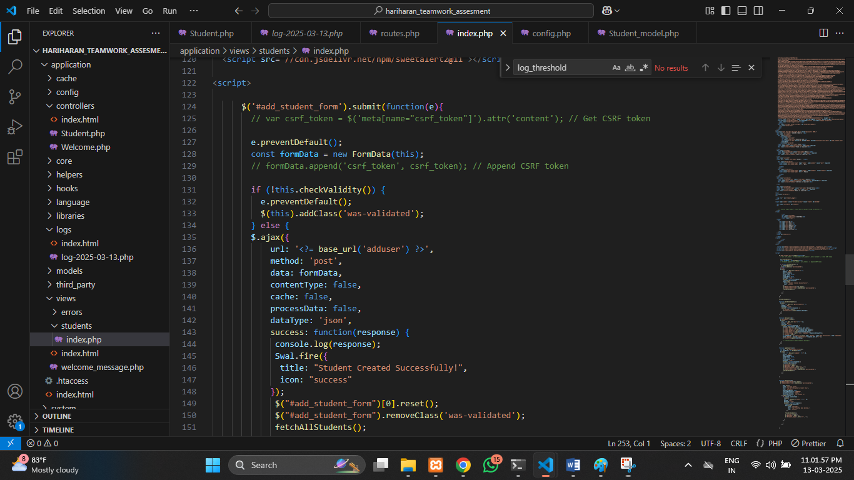  
  
2.form validation   
  
 both frontend and backend